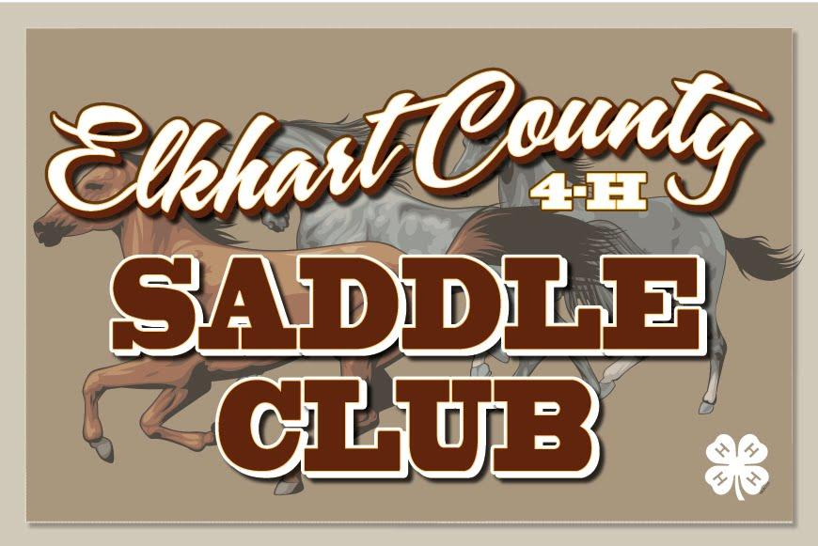

**Elkhart County 4-H Saddle Club – Meeting Agenda for May 12th, 2025**

* **6:30 New Members /Family Meeting** (Heather Riegsecker)
* **7:00 meeting brought to order** – President: Carley Miller
  + Pledges
  + Minutes – Emma G. Yoder
  + Health & Safety – Lilly Yoder
* **Old Business**:
  + **Horse Enrollments** - now available online through MAY 15th!!! This is a state deadline!! **If you miss this deadline, you will need to complete a poster instead, as we are not able to add anyone after May 15th!** Check to see current horse enrollments at the Completion table. – Ashley King
    - Please sign up ALL horses you have access to as a backup. Horses not signed up are ineligible to be shown at fair. If you do not have a backup and you are unable to show a horse at fair for whatever reason, you MUST complete a poster to complete your project – Ashley King
  + **Horse Use by others**: NO ONE other than a sibling may show a horse/pony registered with a 4-Her or leased by a 4-Her in a judged class after MAY 15th to be eligible to show at fair!!!!! - Ashley King
  + **Open Shows** - Club open show dates are listed in the survival guide; show bills posted on the club website as well as patterns. Volunteers to help run the shows. - Sierra Cross
    - MAY OPEN SHOW: Saturday the 18th – Speed; Sunday the 19th – Pleasure
      * This show will open our High Point season!!!
  + **Leases** – Need a horse to lease for the year, or if you have a horse available? See Leases table.
    - **YOU MUST HAVE ALL SIGNED LEASE PAPERWORK SUBMITTED BY MAY 15TH**
    - These will need to be uploaded online **AND** turned into Jen Meyer
  + **Club T-shirts** – Still available to order
* **New Business**:
  + **Horse Camp** – **accepting applications for 1st through 2nd year members** wishing to attend camp as well as Junior Leader applications and Adult Volunteers. Applications Due tonight!! – Bekah McKerchie
  + **Work Shifts** - You must be signed up by May 15th for all work shifts – Jennifer Yeager
  + **10 Year and retiring Members** – please see Michelle Cross for all information to successfully complete your final year and for your jacket fitting, which needs to be completed by MAY 15th!! – Michelle Cross
  + **ITEMS DUE MAY 15TH: Ashley King**
    - PROOF OF VACCINATIONS (uploaded with horse enrollment **AND** turned into leadership)
    - WORKSHIFTS SIGNED UP FOR
    - **HORSES & PONIES ENROLLED** (or a poster turned in if not showing a horse/pony)
    - LEASE AGREEMENTS (uploaded with horse enrollment **AND** turned into leadership)
* **Meeting Topic:** **1st through 3rd Year Member Level Sheets**
* **Items to pick up or receive at tonight’s meeting**:
  + 2024 Horse and Pony Handbook
    - If you have already picked one up, please do not take another. The club provides one per family.
  + Completion Pins/Awards as needed
* **Do Online**:
  + Find our website: [www.elkhartcounty4hsaddleclub.com](http://www.elkhartcounty4hsaddleclub.com)
  + Find us on Facebook!! Elkhart County Saddle Club
  + Text Alerts: Text your name and ‘join2025’ to 574-370-6421 to be added
* **4-H Member Sign-Up Opportunities**
  + Mid-States
  + Drill Team
  + Horse Camp
* **Next Month**:
  + Meeting on Monday, June 9th, 2025, at the Sheep Swine Arena
    - 6:30 1st & 2nd Year members/families
    - 7:00 Club Meeting
* **Club Open Shows**:
  + - May 17th – 18th
      * High Point Classes Offered
    - June 21st – 22nd
      * High Point Classes Offered
    - July 11th – 13th
      * Fair Practice Show
      * Friday: Jumping/Dressage
      * Saturday: AM – English; PM – Speed
      * Sunday: Western
    - August 9th – 10th
      * High Point Classes Offered